DISHES AND THEIR ALLERGEN Chart SNADWITCHES & PACK LUNCHES (Note – Please state the name of the cereal(s) containing gluten** in that column AND/OR the name of the nut(s)* in that column)
DISHES | 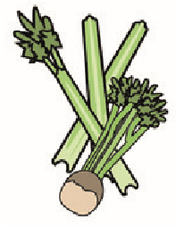 | 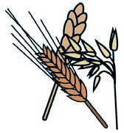 | 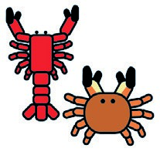 | 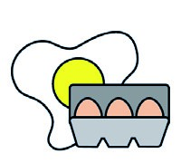 | 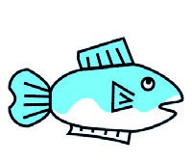 | 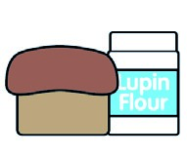 | 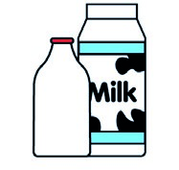 |  | 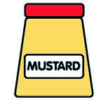 | 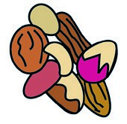 | 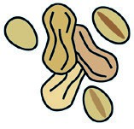 | 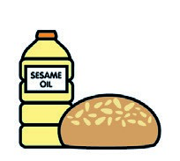 | 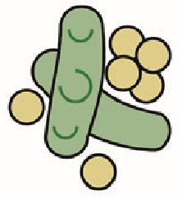 | 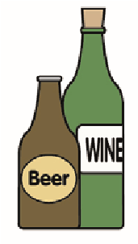
 | Celery | Cereals containing gluten** | Crustaceans | Eggs | Fish | Lupin | Milk | Molluscs | Mustard | Nuts* | Peanuts | Sesame seeds | Soya | Sulphur dioxide
ROLL |  | ✓ |  |  |  |  | ✓ |  |  |  |  | ✓
WRAP |  | ✓ |  | ✓ |  |  | ✓
BUTTER |  |  |  |  |  |  | ✓
RASINS
YOGHURTS  *STRAWBERRY |  |  |  |  |  |  | ✓
CUCAMBER
HAM |  | ✓ |  |  |  |  | ✓
CHEESE |  |  |  |  |  |  | ✓
HAM/CHEESE |  |  |  |  |  |  | ✓
TUNA MAYO |  |  |  | ✓ | ✓
SAUSAGES | ✓ | ✓ |  | ✓ |  |  | ✓
Chicken mayo |  |  |  | ✓ |  |  | ✓
Egg mayo |  |  |  | ✓
Jam
*low sugar & straw.

01/09/2024. JOANNA PISKULA
Review date: Reviewed by: You can find this template, including more information at www.food.gov.uk/allergy

